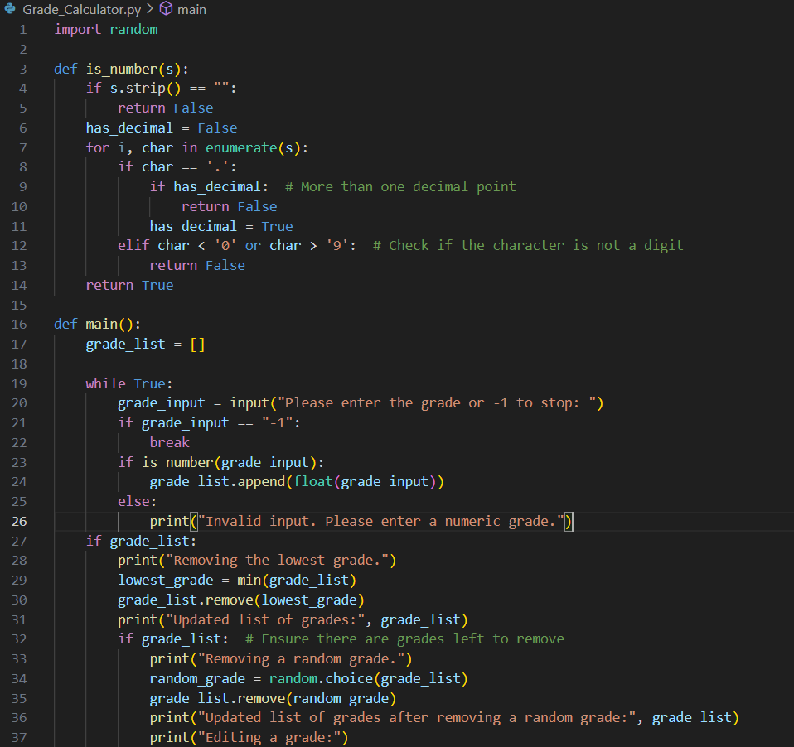

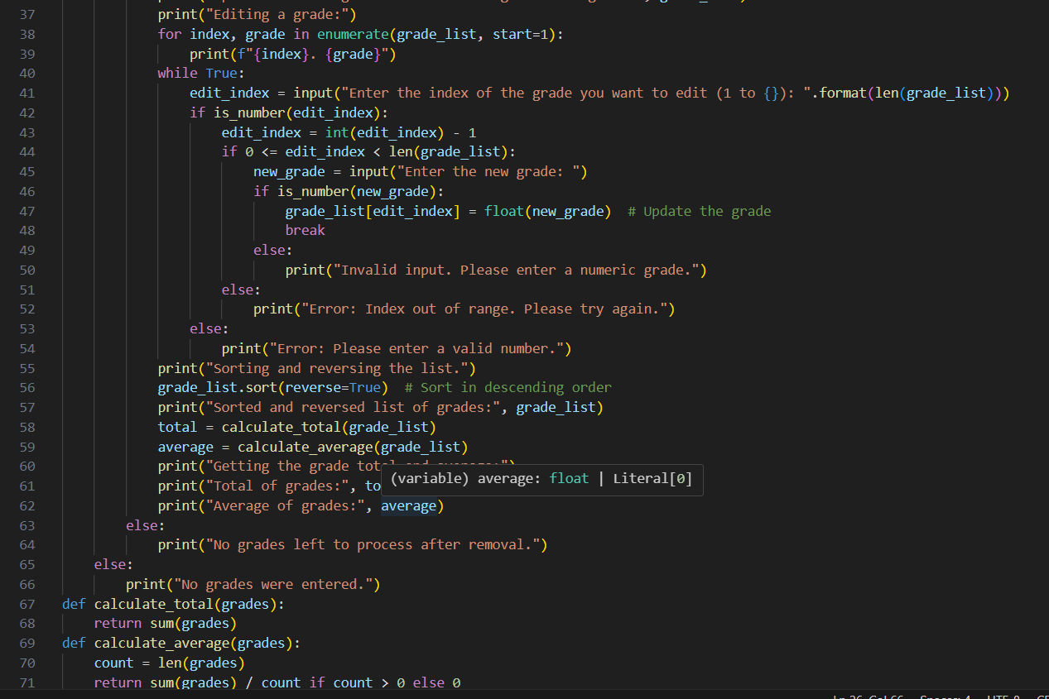

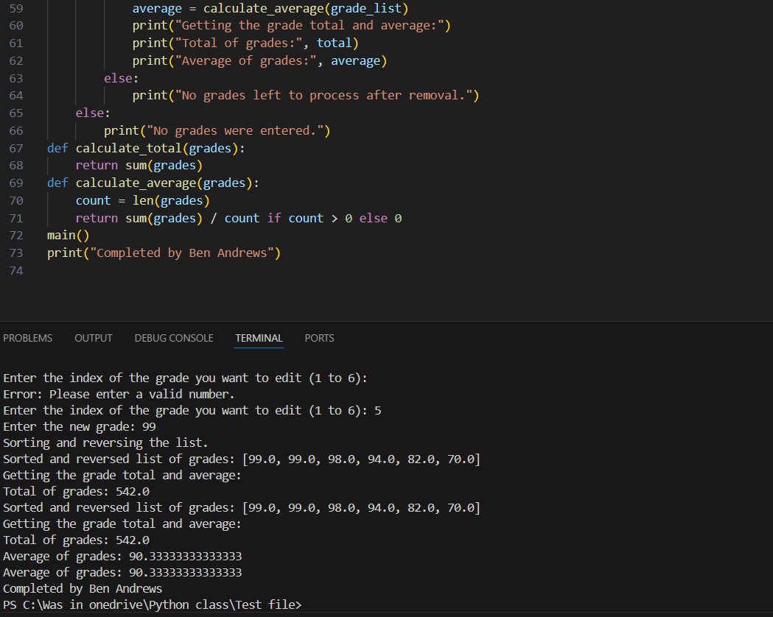

import random

def is_number(s):

if s.strip() == "":

return False

has_decimal = False

for i, char in enumerate(s):

if char == '.':

if has_decimal: # More than one decimal point

return False

has_decimal = True

elif char < '0' or char > '9': # Check if the character is not a digit

return False

return True

def main():

grade_list = []

while True:

grade_input = input("Please enter the grade or -1 to stop: ")

if grade_input == "-1":

break

if is_number(grade_input):

grade_list.append(float(grade_input))

else:

print("Invalid input. Please enter a numeric grade.")

if grade_list:

print("Removing the lowest grade.")

lowest_grade = min(grade_list)

grade_list.remove(lowest_grade)

print("Updated list of grades:", grade_list)

if grade_list: # Ensure there are grades left to remove

print("Removing a random grade.")

random_grade = random.choice(grade_list)

grade_list.remove(random_grade)

print("Updated list of grades after removing a random grade:", grade_list)

print("Editing a grade:")

for index, grade in enumerate(grade_list, start=1):

print(f"{index}. {grade}")

while True:

edit_index = input("Enter the index of the grade you want to edit (1 to {}): ".format(len(grade_list)))

if is_number(edit_index):

edit_index = int(edit_index) - 1

if 0 <= edit_index < len(grade_list):

new_grade = input("Enter the new grade: ")

if is_number(new_grade):

grade_list[edit_index] = float(new_grade) # Update the grade

break

else:

print("Invalid input. Please enter a numeric grade.")

else:

print("Error: Index out of range. Please try again.")

else:

print("Error: Please enter a valid number.")

print("Sorting and reversing the list.")

grade_list.sort(reverse=True) # Sort in descending order

print("Sorted and reversed list of grades:", grade_list)

total = calculate_total(grade_list)

average = calculate_average(grade_list)

print("Getting the grade total and average:")

print("Total of grades:", total)

print("Average of grades:", average)

else:

print("No grades left to process after removal.")

else:

print("No grades were entered.")

def calculate_total(grades):

return sum(grades)

def calculate_average(grades):

count = len(grades)

return sum(grades) / count if count > 0 else 0

main()

print("Completed by Ben Andrews")